InvestiMapp

**January 25, 2018**

Ryan Hutchinson, Wesley Scott, Chris Baierski, Jairus McElroy, Yanan Hao, Darrel Donald

# Overview

App Name: **InvestiMapp**

App Category: **Finance**

The idea for this application came from the current selection of investment and portfolio applications on the market, which has become oversaturated with apps that are hard to use and do not give users an intuitive way to easily see their successes and failures. It is either red or green. That could be barely red or barely green and with a quick glance it is hard to see with what magnitude you are succeeding or failing.

Investing app will be a web application that will hold investment portfolio information and report on portfolio the magnitude of the individual users success or failure. The application will contain specific user information therefore it will have a user account login and database with user data. The main focus of the web application will be ease of use and a functionally beautiful user interface.

# Overview of Similar Apps

## Robinhood - Mobile App and Web App

Robinhood is a full trading platform. The comparison being made to this app will be to the progress tracking portion only. We will not compete with Robinhood in trading. Their application does not show overall net gain on a shares owned on a company. It is very hard to see what investment is lowering your portfolio and what is raising it.

All the values with the red overlay are in relation to the current market and not to the amount in which you paid for the shares in the company.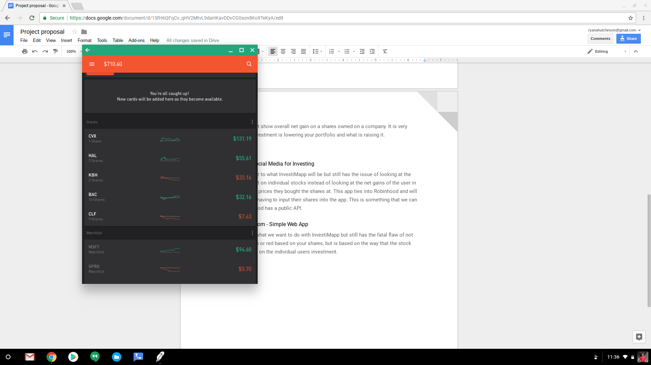

## StockTwits - Social Media for Investing

StockTwits is closer to what InvestiMapp will be but still has the issue of looking at the overall stock market on individual stocks instead of looking at the net gains of the user in relation to the what prices they bought the shares at. This app ties into Robinhood and will keep the user from having to input their shares into the app. This is something that we can look into if Robinhood has a public API.

## MarketWatch.com - Simple Web App

This website does what we want to do with InvestiMapp but still has the fatal flaw of not making things green or red based on your shares, but is based on the way that the stock opened that day not on the individual users investment. MarketWatch is also not a very good looking web application that is riddled with advertisements.